«BrickType»  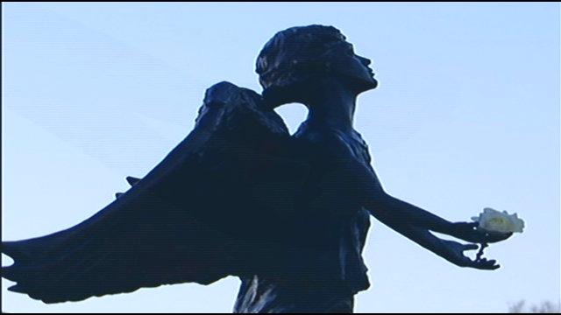 | Angel of Hope Children’s Memorial Park  Making a Memory for Our Children  Order a beautiful Angel Memorial – a remembrance for your child.  This beautiful memorial tile will last a life time – custom engraved in memory of your child.
The Angel of Hope Children’s Memorial Park located on the South Shore of Silver Lake in Virginia, will be part of a national and international network of memorial parks that provide a place of comfort and hope to parents and family members who grieve the loss of a child, regardless of age or reason. The initial memorial statue and subsequent memorial parks were inspired by the book
“The Christmas Box” by the author Richard Paul Evans.

To honor our children’s memories, memorial tiles will be placed on the memorial wall. The wall extends behind the Angel statue. The statue and surrounding area is intended to be a place of peace for all bereaved parents, grandparents, relatives and friends.

Personalized Tile  4” x 8” 1 – 3 lines  $200 | Personalized Tile  8” x 8” 1 – 6 lines  $300 | Replica Bricks - (for your own use)  Replicas will be a matching  duplicate of the ordered tile

Purchaser Information

Name ______________________________________ Street Address _________________________________________________

City _______________________________________ State _______________________ Zip ______________________________

Daytime Phone Number ___________________________ Email ____________________________________________________
In Memory of: _________________________ Notify the following of my gift: Name __________________________________
Address ________________________________
Tile Size Selection

______ 4 x 8 personalized tile = $200 | Tile Cost | $
______ 8 x 8 personalized tile = $300 | Replica Brick | $
Replica Brick /Personal Commemorative with purchase of tile above | Total Cost | $
______ 4 x 8 personalized brick = $100 (available only with 4 x 8 tile purchase) | Payment Type  (for recordkeeping only) | Check #
______ 8 x 8 personalized brick = $200 (available only with 8 x 8 tile purchase)

PLEASE PRINT carefully the inscription that you would like to be engraved on your memorial tile. Your message must fit within the spaces provided and will appear on the tile exactly as shown. Maximum 15 spaces per line, including characters, punctuation, dashes, ampersands, symbols and blank spaces. All inscriptions are centered in CAPITAL letters. If you wish to order more than one tile, please reproduce this form. Children’s Memorial Park reserves the right to approve all tile inscriptions.

Line 1 for 4 x 8 and 8 x 8 tiles
Line 2 for 4 x 8 and 8 x 8 tiles
Line 3 for 4 x 8 and 8 x 8 tiles
Line 4 for 8 x 8 tile only
Line 5 for 8 x 8 tile only
Line 6 for 8 x 8 tile only
Return this form with check or money order to: Children’s Memorial Park, 1114 South 12th Street, Virginia, MN 55792.
Memorial tile orders will be accepted through May 15th each year, to guarantee installation for this year. Orders received after May 15th, will be installed the following year. Limited space is available.
Please make checks payable to our fiscal agent: City of Virginia (note: Children’s Memorial Park)
PLEASE CALL (218) 749-5642 WITH QUESTIONS. Watch our website for updates www.childrensmemorialparkmn.org
(6/2017)

