«BrickType»  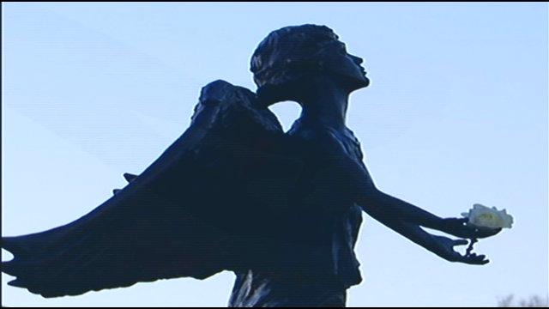 | Angel of Hope Children’s Memorial Park  Making a Memory for Our Children  Memorial Trees
The Angel of Hope Children’s Memorial Park located on the South Shore of Silver Lake in Virginia, will be part of a national and international network of memorial parks that provide a place of comfort and hope to parents and family members who grieve the loss of a child, regardless of age or reason. The initial memorial statue and subsequent memorial parks were inspired by the book
“The Christmas Box” by the author Richard Paul Evans.

Personalized
Bronze Plaque
6” x 6” 1 – 3 lines

Purchaser Information:

Name ______________________________________ Street Address _________________________________________________

City _______________________________________ State _______________________ Zip ______________________________

Daytime Phone Number ___________________________ Email ____________________________________________________

In Memory of: _________________________ Notify the following of my gift: Name ________________________________
Address ________________________________

Notes:

 | Plaque Cost ($300) | $
 | Tree ($200) | $
 | Total Cost | $ 500.00
 | Payment Type  (for recordkeeping only) | Check #

PLEASE PRINT carefully the inscription that you would like to be engraved on your memorial plaque. Your message must fit within the spaces provided and will appear on the tile exactly as shown. Maximum 15 spaces per line, including characters, punctuation, dashes, ampersands, symbols and blank spaces. All inscriptions are centered in CAPITAL letters. Children’s Memorial Park reserves the right to approve all memorial plaque inscriptions.

Line 1
Line 2
Line 3

Return this form with check or money order to: Children’s Memorial Park, 1114 South 12th Street, Virginia, MN 55792.
Please make checks payable to our fiscal agent: City of Virginia (note: Children’s Memorial Park)
PLEASE CALL (218) 749-5642 WITH QUESTIONS. Our website = www.childrensmemorialparkmn.org

September 2021

